**Analysis of Covid-19 Vaccines**

1. **Data Exploration**

## Dataset Overview

The dataset comprises the following key attributes:

1. country
2. total_vaccinations
3. vaccines
4. **Exploratory Data Analysis and Data Visualisation**

# 2.1 Initial Exploration

* Loaded the dataset and conducted an initial exploration using describe() and info()
* When validating for null values we have found the following no of rows having missing cells

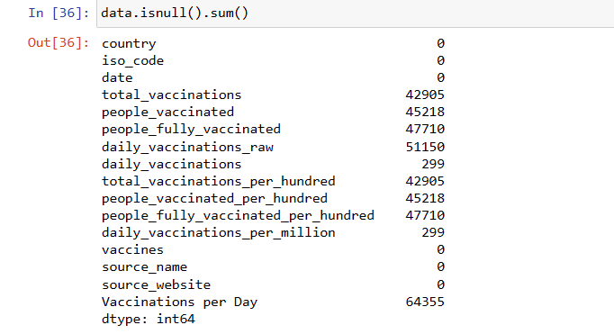

# 2.2 Extracting Unique vaccines from the data set

With this we have acquired the names of all the vaccines which are supplied across the globe.

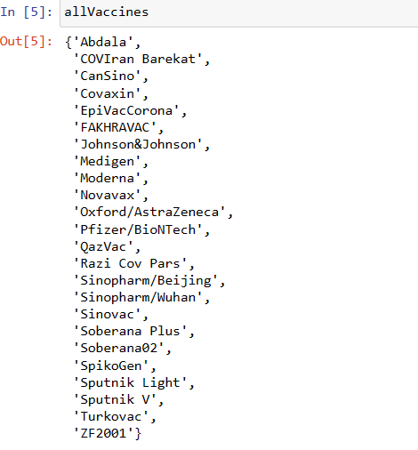

A total of 24 vaccines were acquired from the given dataset.

# 2.3 Finding Widely Distributed Vaccines Across Countries

Through the execution of a code snippet, we have successfully identified the countries to which these companies have supplied their vaccines. Leveraging frequency data, we crafted a comprehensive graph illustrating the leading suppliers in the global vaccine distribution landscape.

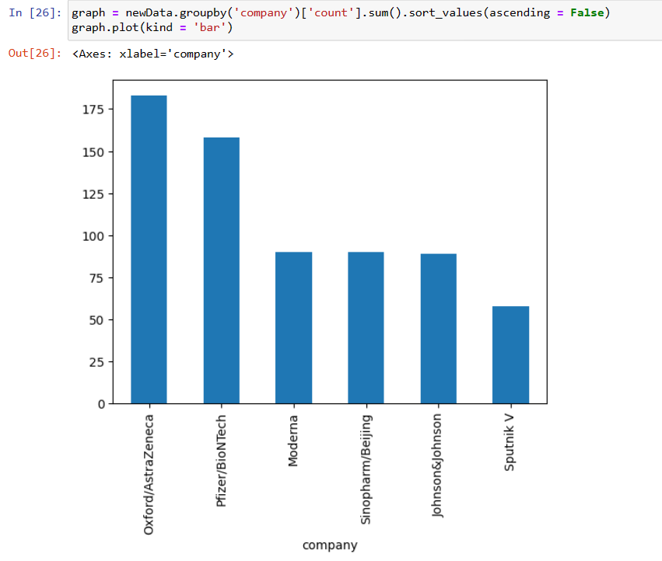

# 2.4 Nations Leading in Advanced Vaccination Initiatives

Countries with the highest number of vaccinated individuals are indicative of advanced vaccination programs. The accompanying graph illustrates the notable leaders in vaccination coverage, providing a visual representation of the nations at the forefront of advanced vaccination initiatives.

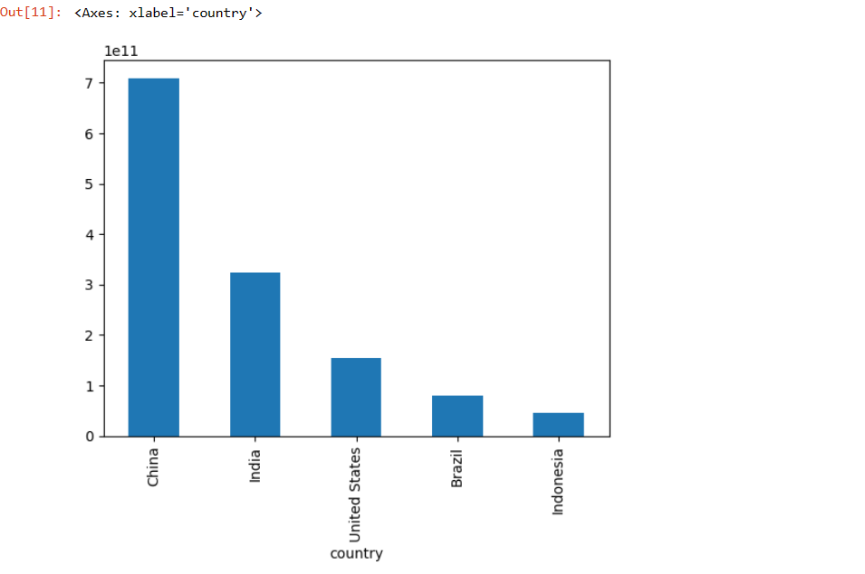

|  |  |
| --- | --- |
| **Category** | **Description** |
| **Vaccines** | Oxford/AstraZeneca, Pfizer/BioNTech, Sinopharm/Beijing, Moderna, Johnson&Johnson, and Sputnik V emerged as the leading suppliers among 24 companies. |
| Countries | China, India, the United States, Brazil, and Indonesia, representing the most populated nations, stood out as leading consumers of Covid-19 vaccines among the 223 countries listed in the dataset. |

**3. Conclusion**

As we move beyond Covid, our vaccine analysis highlights global immunization insights. Key suppliers, including Oxford/AstraZeneca and Pfizer/BioNTech, and nations like China and India demonstrated advanced vaccination efforts. Diverse vaccines and strategic distribution underscore our resilience. These findings testify to global collaboration in crisis response. Looking ahead, lessons learned will shape future public health and pandemic preparedness.